Concept of cyber-physical system for intelligent husbandry farm
Nayden Chivarov¹, Denis Chikurtev^{1,} Stefan Chivarov¹,
Stefka Atanasova², Toncho Penev², Anastasia Yovanovska³
¹Institute of Information and Communication Technologies at Bulgarian Academy of Sciences, nchivarov@gmail.com; dchikurtev@gmail.com; schivarov@gmail.com
²Trakia University, s.atanassova@gmail.com, tonchopenev@abv.bg
³ University of Library Studies and Information Technologies, anastasiajovanovska999@gmail.com

The cyber-physical system (CPS) is a new generation digital system that consists of two main functional components: extended connectivity, which provides real-time data collection from the physical world and feedback from cyberspace; intelligent data management, analytics, and computing capabilities that make up cyberspace.
Cyber-physical systems are characterized by great complexity because they combine many technologies and devices. Research approaches in the field of CPS are characterized by the separation of some of the constituent components of this type of systems and subsequent research and improvement. In this way, on the one hand, the complexity of simultaneous research of complex technologies or devices is reduced and on the other hand, there is an opportunity for a more detailed and in-depth introduction to the issues of the individual components. In addition, it is necessary to study the compatibility and interaction between the individual subsystems in the CPS.
This article presents a model of a cyber-physical system designed to control a smart farm. An overview of modern software technologies used to control Cyber-physical systems is presented. Communication technologies used in remote control systems and in particular web technologies for data provision are considered. Modern platforms and software frameworks for realization of web services and provision of functions for remote control and monitoring have been studied. Based on the conducted research, a specialized model of Cyber-physical system has been developed and presented, which would meet the needs and criteria for management of smart farms. Based on the presented model, experiments were performed with different temperature sensors and humidity sensors. The results of the experiments show that the developed system has the necessary functionality and performance to cope with the tasks.
Sensors belong to the main elements of CPS, as they measure physical properties and allow for adequate behavior. Because the CPS is event-driven, the integration and visualization of sensor values is an important factor for the control center.
The brain of the Cyber-physical system is represented as the control center / server. This is where all the information about the Cyber-physical system is processed. In order to ensure adequate user interaction with it, it is necessary to create a graphical user interface. The graphical interface allows the user to enter data and get output. The presented Cyber-physical system is based on OpenHab technology, which is one of the most used in the field of Internet of Things and smart homes. Tests with different sensors measuring humidity and temperature are performed. Preliminary results are presented on fig. 1 and fig. 2.

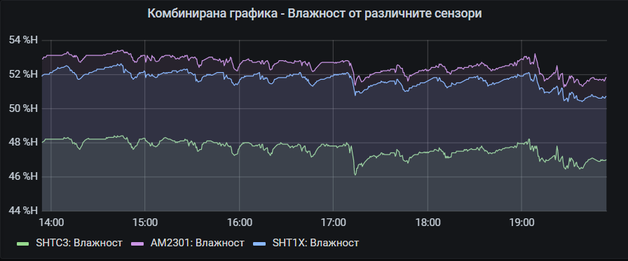
Fig. 1 Combined humidity graphics from different sensors

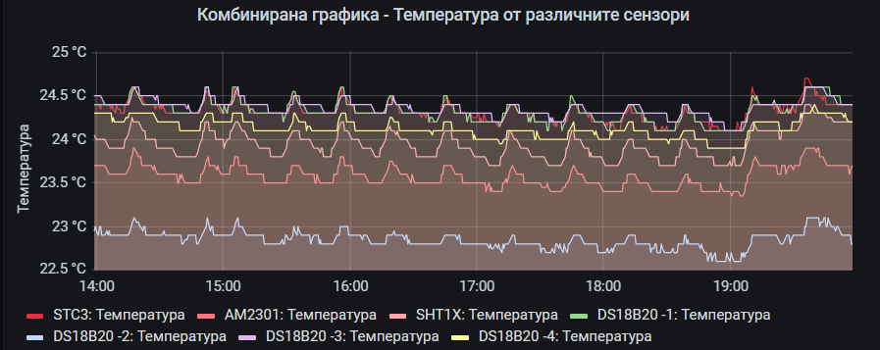
Fig. 2 Combined temperature graphics from different sensors

The corresponding author data must be written at the end of the abstract:
Corresponding author:
Nayden Chivarov
Institute of Information and Communication Technologies at Bulgarian Academy of Sciences
e-mail: nchivarov@gmail.com

Options indication
1. Indicate your option for the presentation: Oral or Poster.
2. Indicate the option for the topic: Electrical Engineering, Electronics and Automatics

